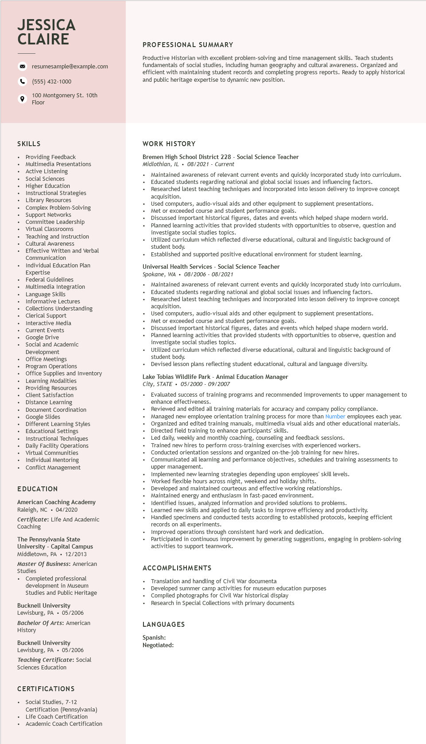
JESSICA CLAIRE
resumesample@example.com
(555) 432-1000
100 Montgomery St. 10th Floor
PROFESSIONAL SUMMARY
Productive Historian with excellent problem-solving and time management skills. Teach students fundamentals of social studies, including human geography and cultural awareness. Organized and efficient with maintaining student records and completing progress reports. Ready to apply historical and public heritage expertise to dynamic new position.
SKILLS
Providing Feedback
Multimedia Presentations
Active Listening Social Sciences Higher Education Instructional Stra
| Strategies
Library Resources
Complex Problem-Solving
Support Networks
suppor
Committee Leadership
Virtual
Classrooms
Teaching and Instruction reaching
Cultural Awareness
Effective Written and Verbal
Communication
Individual Education Plan
Expertise
Experts
Federal Guidelines
Multimedia Integration
Language Skills
Informative Lectures
Collections Understanding
Clerical Support Interactive Media
Current Events
• Google Drive
• Social and Academic
Development
Office Meetings
Program Operations
Office Supplies and Inventory
⚫ Learning Modalities Providing Resources
Client Satisfaction
⚫ Distance Learning
Document Coordination
• Google Slides
Different Learning Styles Educational
Settings
• Instructional Techniques
• Daily Facility Operations Virtual Communities Individual Mentoring
• Conflict Management
EDUCATION
American Coaching Academy Raleigh, NC 04/2020
Certificate: Life And Academic Coaching
The Pennsylvania State University - Capital Campus Middletown, PA • 12/2013 Master of Business: American Studies
• Completed professional development in Museum Studies and Public Heritage
Bucknell University Lewisburg, PA⚫ 05/2006
Bachelor of Arts: American History
Bucknell University
Lewisburg, PA
05/2006
WORK HISTORY
Bremen High School District 228 - Social Science Teacher Midlothian, IL. 08/2021 - Current
.
Maintained awareness of relevant current events and quickly incorporated study into curriculum. Educated students regarding national and global social issues and influencing factors.
Researched latest teaching techniques and incorporated into lesson delivery to improve concept acquisition.
Used computers, audio-visual aids and other equipment to supplement presentations. Met or exceeded course and student performance goals.
• Discussed important historical figures, dates and events which helped shape modern world. Planned learning activities that provided students with opportunities to observe, question and investigate social studies topics.
Utilized curriculum which reflected diverse educational, cultural and linguistic background of student body.
Established and supported positive educational environment for student learning.
Universal Health Services - Social Science Teacher
Spokane, WA. 08/2006- 08/2021
Maintained awareness of relevant current events and quickly incorporated study into curriculum. Educated students regarding national and global social issues and influencing factors.
Researched latest teaching techniques and incorporated into lesson delivery to improve concept acquisition.
Used computers, audio-visual aids and other equipment to supplement presentations. Met or exceeded course and student performance goals.
Discussed important historical figures, dates and events which helped shape modern world. Planned learning activities that provided students with opportunities to observe, question and investigate social studies topics.
Utilized curriculum which reflected diverse educational, cultural and linguistic background of student body.
Devised lesson plans reflecting student educational, cultural and language diversity.
Lake Tobias Wildlife Park - Animal Education Manager City, STATE
05/2000-09/2007
Evaluated success of training programs and recommended improvements to upper management to enhance effectiveness.
Reviewed and edited all training materials for accuracy and company policy compliance. Managed new employee orientation training process for more than Number employees each year. Organized and edited training manuals, multimedia visual aids and other educational materials. Directed field training to enhance participants' skills.
Led daily, weekly and monthly coaching, counseling and feedback sessions. Trained new hires to perform cross-training exercises with experienced workers. Conducted orientation sessions and organized on-the-job training for new hires. Communicated
comm all learning and performance objectives, schedules and training assessments to upper management.
Implemented new learning strategies depending upon employees' skill levels. Worked flexible hours across night, weekend and holiday shifts.
Developed and maintained courteous and effective working relationships.
Maintained ener
d energy and enthusiasm in fast-paced environment.
Identified issues, analyzed information and provided solutions to problems.
Learned new skills and applied to daily tasks to improve efficiency and productivity.
Handled specimens and conducted tests according to established protocols, keeping efficient records on all experiments.
Improved operations through consistent hard work and dedication.
Participated in continuous improvement by generating suggestions, engaging in problem-solving activities to support teamwork.
ACCOMPLISHMENTS
Translation and handling of Civil War documenta
Developed summer camp activities for museum education purposes
Compiled photographs for Civil War historical display
Research in Special Collections with primary documents
LANGUAGES
Spanish: Negotiated:
Teaching Certificate: Social
Sciences Education
CERTIFICATIONS
• Social Studies, 7-12
Certification (Pennsylvania)
• Life Coach Certification
• Academic Coach Certification

